**Assignment 2**

**Name :** Gandhi Pritesh

1)  Topology created in Microsoft Visio :

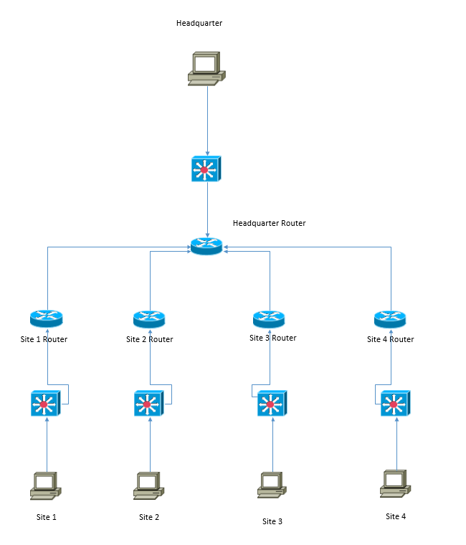

2)  Brief Description of what topic or technology you are concentrating on within this journal.

=>

* The main topic in this assignment is VLSM (Variable Length Subnet Mask).
* As we know while assigning IP address, lot of IP gets wasted because of unnecessary extra IP addresses given to a network as they are calculated on the basis of the maximum IP address required in the network. This wastage of IP address cannot be stopped , however, it can be reduced using VLSM.
* In VLSM, the IP address are divided into the subnets so that the requirement will be fulfilled & the wastage of IP addresses could be minimized.
* As per the given question, Company VARIABLE is a manufacturer of robotic birds used for U.S. military reconnaissance missions.  VARIABLE is a growing company and needs to utilize their IP Addresses in the most efficient way possible.  They are using the RFC1918 network address of 192.168.37.0/24.  VARIABLE has one headquarters site with 15 employees.  They also have four other remote sites each with 10 employees.
* Here if we follow the traditional method then the network address 192.168.37.0/24 will be divided into 8 subnets, each will have 32 IP addresses as the maximum required usable host addresses are 15 at headquarter. Other 4 sites need only 10 host addresses each. In this case, the remaining IP addresses will be waste.
* On the other hand, if we go with VLSM method, then we can obtain 1 subnet of 32 IP addresses for the headquarter & 4 subnets of 16 IP addresses for 4 sites. This will save 16 IP addresses at each site. So Total = 16 x 4 = 64 IP addresses will be saved which is huge saving.
* Calculation of subnets using VLSM is done as follow:

.0

.0 .128

.0 .64 .128 .192

.0 .32 .64 .96 .128

.0 - .31 Assigned to Headquarter LAN

.32 .48 .64 .80 .96 .112 .128

.96 .104

4 networks, each assigned to one of the four remote sites

.96 .100 .104 .108

Assigned to each router-router connection

|  |  |  |  |  |  |
| --- | --- | --- | --- | --- | --- |
| **Subnets** | **Needed Hosts** | **Network Address** | **Mask** | **Assignable Range** | **Broadcast** |
| **Headquarter** | 15 | 192.168.37.0 | 255.255.255.224 | 192.168.37.1 - 192.168.37.30 | 192.168.37.31 |
| **Site 1** | 10 | 192.168.37.32 | 255.255.255.240 | 192.168.37.33 - 192.168.37.46 | 192.168.37.47 |
| **Site 2** | 10 | 192.168.37.48 | 255.255.255.240 | 192.168.37.49 - 192.168.37.62 | 192.168.37.63 |
| **Site 3** | 10 | 192.168.37.64 | 255.255.255.240 | 192.168.37.65 - 192.168.37.78 | 192.168.37.79 |
| **Site 4** | 10 | 192.168.37.80 | 255.255.255.240 | 192.168.37.81 - 192.168.37.94 | 192.168.37.95 |
| **WAN1** | 2 | 192.168.37.96 | 255.255.255.252 | 192.168.37.97 - 192.168.37.98 | 192.168.37.99 |
| **WAN2** | 2 | 192.168.37.100 | 255.255.255.252 | 192.168.37.101 - 192.168.37.102 | 192.168.37.103 |
| **WAN3** | 2 | 192.168.37.104 | 255.255.255.252 | 192.168.37.105 - 192.168.37.106 | 192.168.37.107 |
| **WAN4** | 2 | 192.168.37.108 | 255.255.255.252 | 192.168.37.109 - 192.168.37.110 | 192.168.37.111 |